For UML diagrams we can use LucidCharts, it’s a free application for google chrome, so it’s available on all operating systems.

It can be found here: <https://www.lucidchart.com/>

We should imitate cobalt’s:

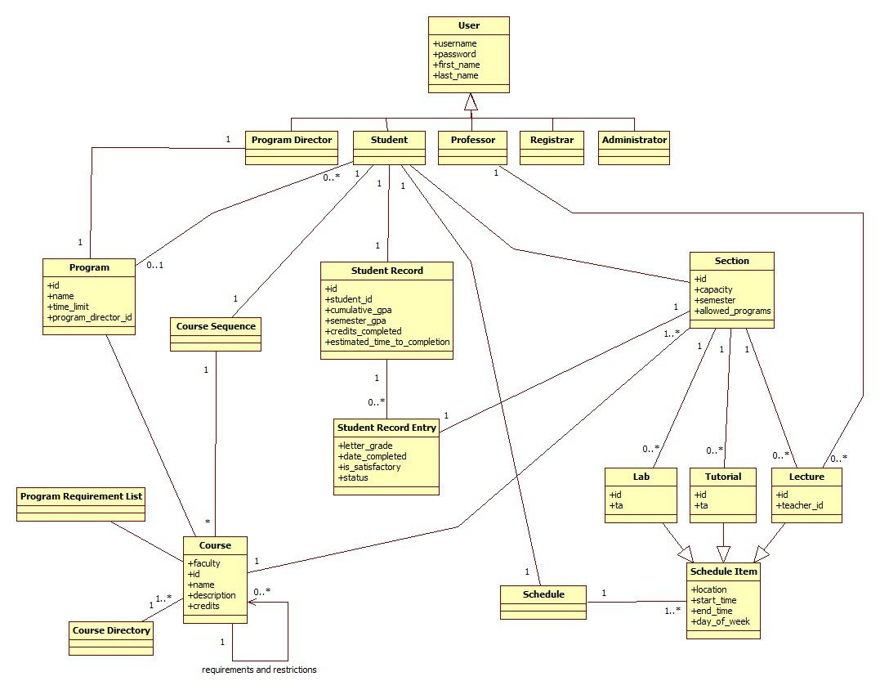

Example of Bacon:

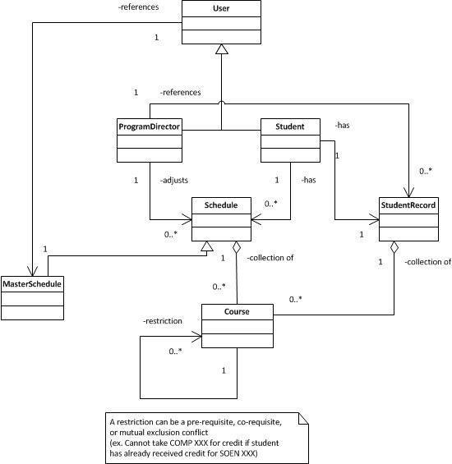

Example of Stars:

